CPE 403 ADV EMB SYS DES FL 2016

TITLE: Midterm

Goals: To obtain and report Lux sensor TSL2561 data to IOT website Thingspeak

Links:

**Github** - <https://github.com/galveg1/VMs_House-of-Fun-Or-Pain>

**Youtube** - <https://youtu.be/Koq14p45KUM>

**Steps**:

1- Declared a char array variable for pushing data unto Thing

speak through an ESP8255-01 module

2- Set clock to 40MHz

3- Decalred variables for lux, lux average and index

4- Configure UART, I2C, TSL2561 and Enable Hibernate using provided libraries

5- Print AT commands to UART for setting up the BAUD rate

, Connection and mode of ESP8266-01

6- A for(;;) loop was used inside the main while loop to

collect and sum 20 data point from the sensor

then it was averaged and pushed unto Thingspeak approximately every 15s.

7- Used i2c communications between Tivac 1350 Launchpad to obtain lux values

9- Used UART1 to communicate to ESP8266 which pushed data to Thingspeak.

10- Using the TSL2561 required us to set the command bit, address and data bits

**********************************************************

Chip type : ARM TM4C123GH6PM

Program type : Firmware

Core Clock frequency : 40.000000 MHz

**********************************************************/

DELIVERABLES:

C- Code file included on Github

Graph of uploaded data at bottom of this document and spreadsheet file included on Github

**Schematic of circuit**

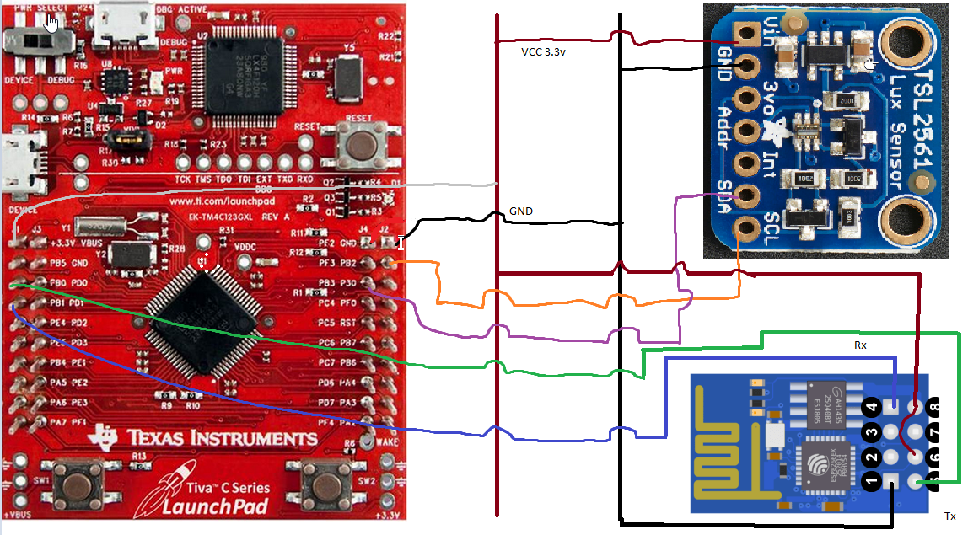

Screen shots

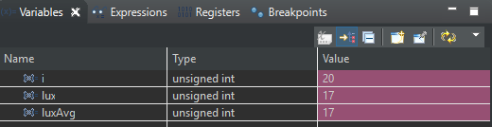

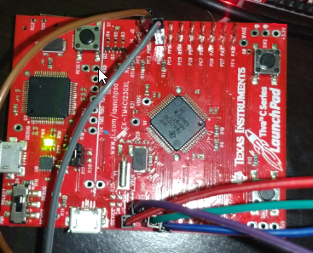 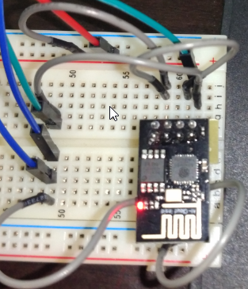

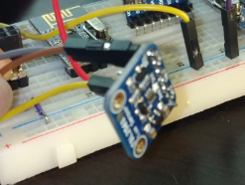

COMPONENTS:

TivaC 1350 LaunchPad

ESP8266-01

TSL2561 Lux Sensor

Bread Board

Jumper wires

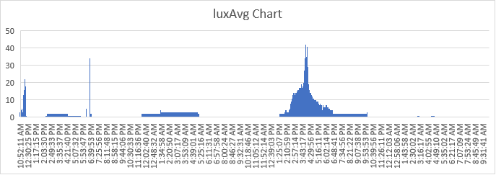

AM Closed Curtain Closed Curtain Open Curtain Asleep

Full data download included in upload.